**Signal Analysis in both time and frequency domain using MATLAB**

**LAB # 04**



**FALL 2021**

**CSE301L-Digital Signal Processing**

Submitted by: **Ashfaq Ahmad**

Registration No: **19PWCSE1795**

Class Section: **B**

“On my honor, as student of University of Engineering and Technology, I have neither given nor received unauthorized assistance on this academic work.”

Student Signature: ______________

Submitted to:

**Prof. Ihsan Ul Haq**

January 13, 2021

**Department of Computer Systems Engineering**

**University of Engineering and Technology, Peshawar**

**Task 01:**

**Will generate the signal of different frequencies say, 10,20,30,40,50,60 Hz using MATLAB as shown in figure 1 and transform the same signal in frequency domain using Fourier transform and will compare the frequencies with the time domain signal as shown in figure 2**

**Code:**

clc

clear all

close all

t=0:0.001:1;

for f=10:10:60;

y=sin(2*pi*f*t);

subplot(3,2,f/10)

plot(t,y)

xlabel('time domain');

ylabel('Amplitude');

title(f);

end

**Output:**

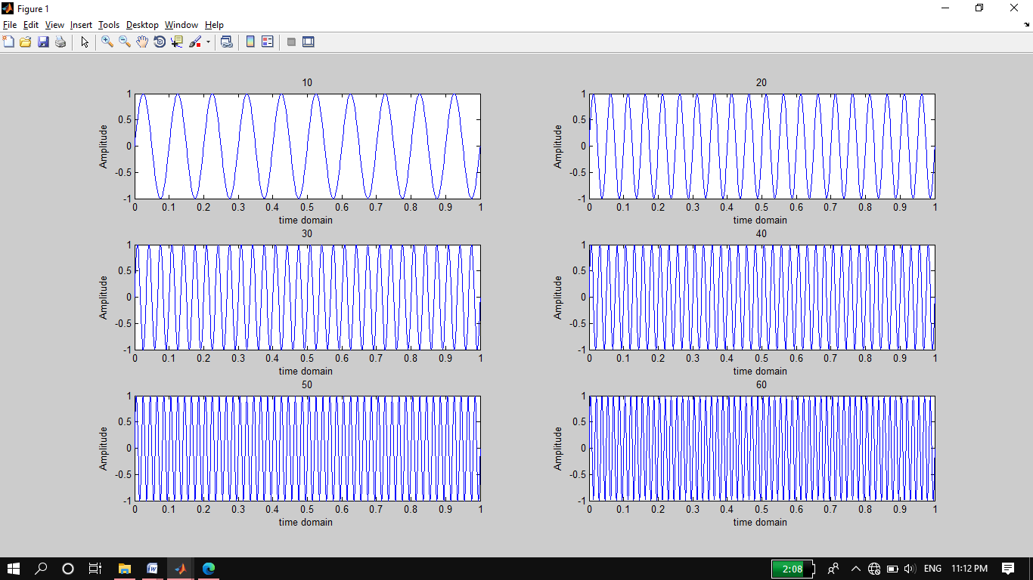

**Frequency domain representation:**

**In frequency domain we take Fourier transform of time domain signal. The code of frequency domain representation and its output is figure2**.

**Source code:**

for f=10:10:60;

y=sin(2*pi*f*t);

n=length(y);

yfft=fft(y,n)

x = (-n/2:n/2-1)*(1000*n); %x-axis

Yshift = (fftshift(yfft));

subplot(3,2,f/10)

plot(x,abs(Yshift))

xlabel('frequency domain');

ylabel('Amplitude');

title(f);

end

**Output:**

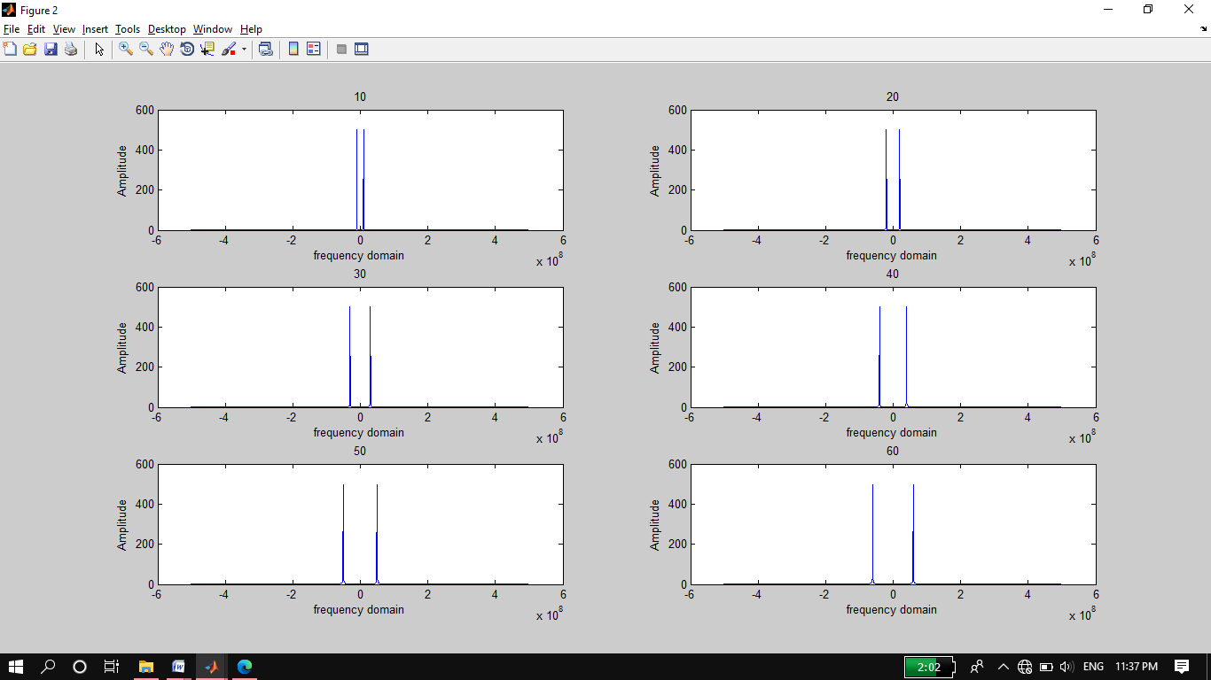

**Task 02:**

**Compare the figure 1 and 2 (Generated by your code)**

A time domain graph shows how a signal changes over time. The frequency domain graph shows how much of the signal lies within each given frequency band over a range of frequencies. The points shows in frequency domain represents starting and ending points of the time domain signal. If we change the frequency of the signal in time domain, we observed in figure 2 that the frequency range is changed it increasing if increase the frequencies.

**Task 03 and 04:**

**>>Add all the signals generated in step 1 and get a composite signal. (Which may be considered as a voice signal)**

**>>Obtain and plot the time and frequency domain representation of the composite signal as shown in figure 3**

In this task we use for loop to generate frequencies signal and adding them named as composite signal. In this code we initialize the value of y is equal to 0 and updated its value using for loop

**Source code:**

y=0;

for f = 10:10:60

t = 0:0.001:1;

y = y+sin(2*pi*f*t);

end

plot(t,y)

xlabel('time in seconds');

ylabel('Amplitude');

title('Composite (Voice) signal ');

**Output:**

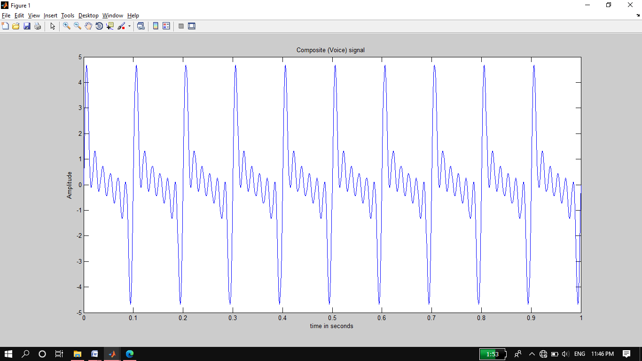

**Frequency Response of Composite Signal**

By taking the Fourier transform of composite time domain signal gets converted into frequency domain representation. The following code is used in matlab which is given below:

**Source code:**

Y =fft(y,length(y));

n = length(Y);

fshift = (-n/2:n/2-1)*(1000*n);

Yshift = (fftshift(Y));

plot(fshift,abs(Yshift));

title('Frequency Response of composite Signal');

**OUTPUT:**

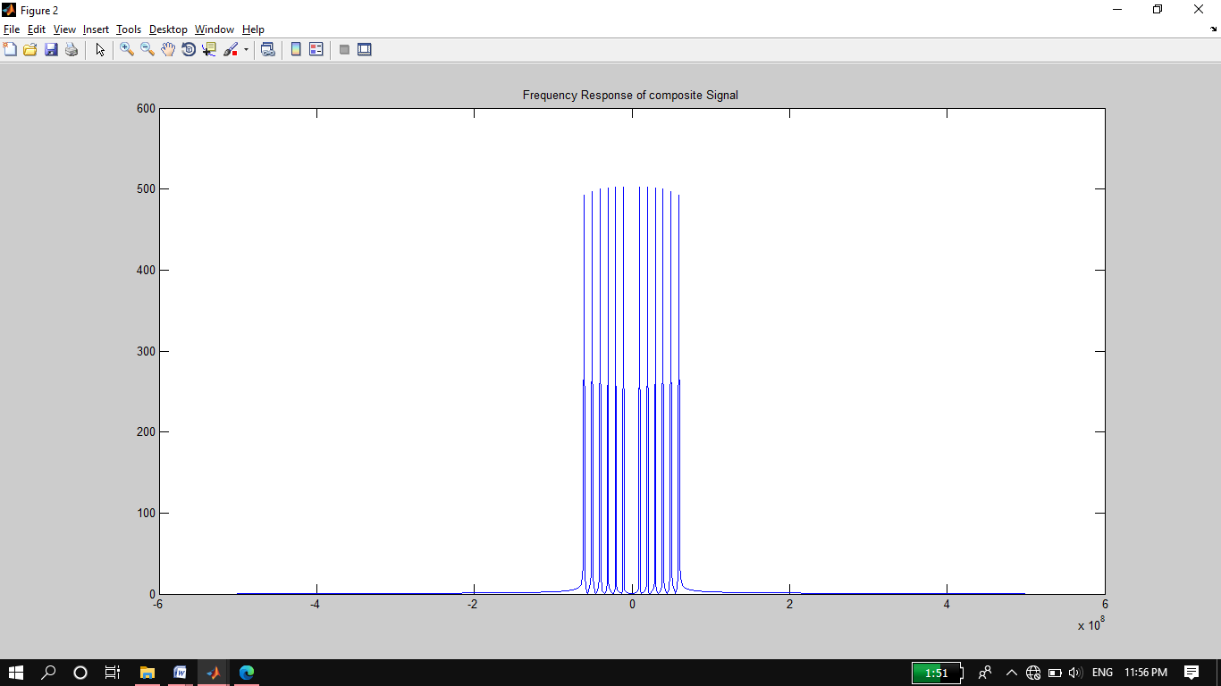

**Task 05:**

**Compare/Confirm that you are getting all the frequency generated in step 1 above.**

in time domain graph it is hard to analyze the signal as compare to frequency domain representation of signal. If look at the frequency representation of the signal then we see the all frequencies of given signals and easy to analyze the signal.

**Task 06 & 07:**

**>>Generate some unwanted signal having frequencies say 80Hz and 100Hz (assume these signal represent noise) and different amplitudes say 0.5 and 0.7**

**>>Obtain both time and frequency representation of noise and confirm they have different Power as shown figure 4.**

In this task we generated two signals as given in the task having frequency of 80 HZ and 100 HZ of amplitude of 0.5 and 0.7 and add these signal to make a noise signal. For analyze we represent these signal in time domain representation of noise signal

**Source code:**

t = 0:0.001:1;

f1 = 80;

A1 = 0.5;

y1 = A1*sin(2*pi*f1*t);

f2 = 100;

A2 = 0.7;

y2 = A2*sin(2*pi*f2*t);

y = y1+y2;

plot(t,y)

xlabel('time in seconds');

ylabel('Amplitude');

title('Noise Signal');

**Output:**

**(Time Domain)**

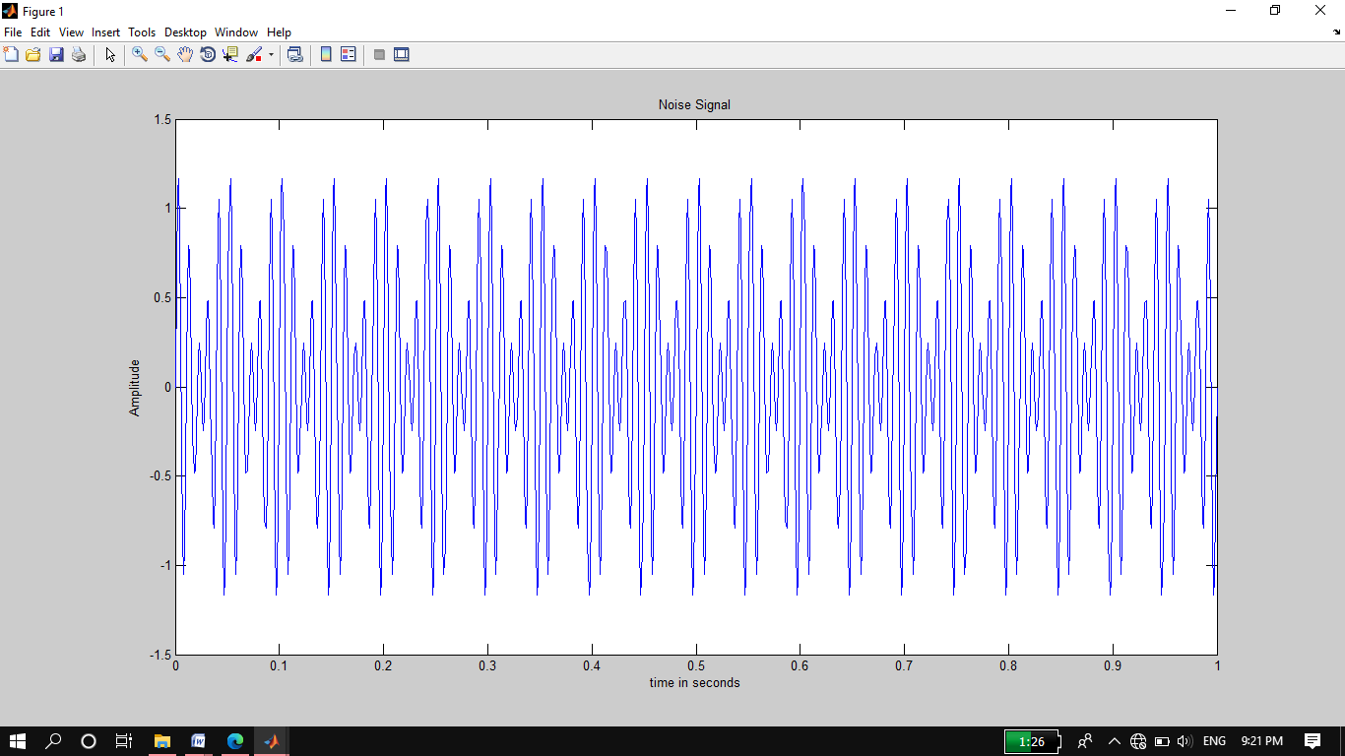

**Frequency domain representation of noise signal:**

**Code:**

n=length(y);

yfft=fft(y,n);

x=(-n/2:n/2-1)*(1000*n);

yshift=fftshift(yfft);

plot(x,abs(yshift));

xlabel('Frequency in Hertz');

ylabel('Amplitude');

title('Noise Signal');

grid on

**Output:**

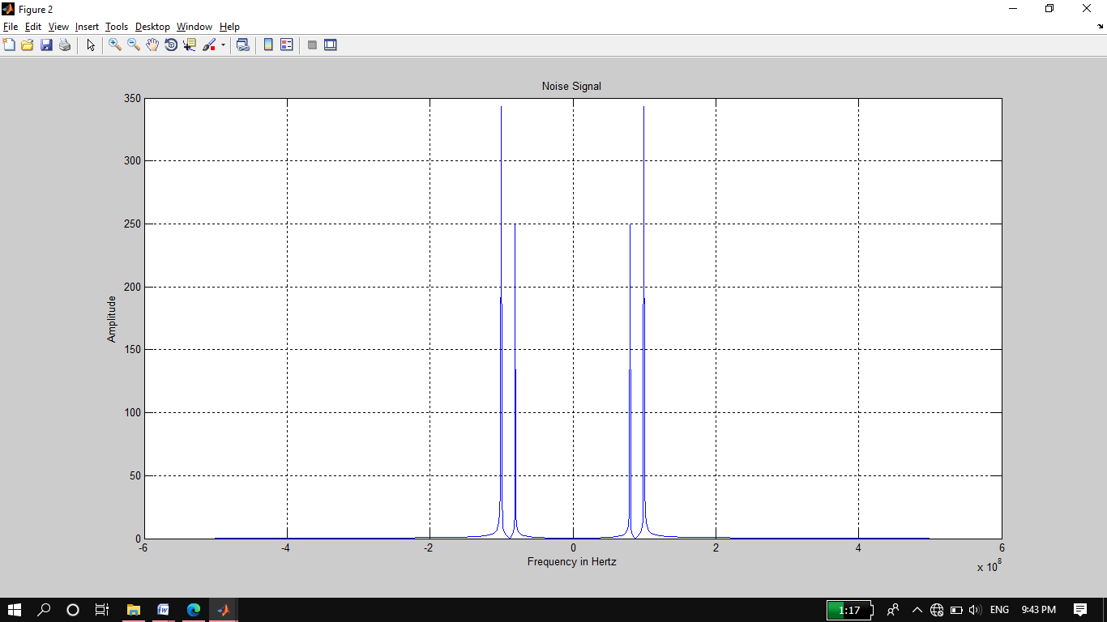

**Task 08:**

**Add the noise to the composite signal (assume the noise is added to the signal during transmission) and obtain frequency spectrum.**

**Source Code:**

clc

clear all

close all

t = 0:0.001:1;

f1 = 80;

A1 = 0.5;

y1 = A1*sin(2*pi*f1*t);

f2 = 100;

A2 = 0.7;

y2 = A2*sin(2*pi*f2*t);

noise = y1+y2; %noisy signal

y = 0;

for f = 10:10:60;

y = y+sin(2*pi*f*t); %composite signal

end

variance = y+noise;

plot(t,variance);

title('Noise plus Composite Signal');

**Output:**

**(Time Domain)**

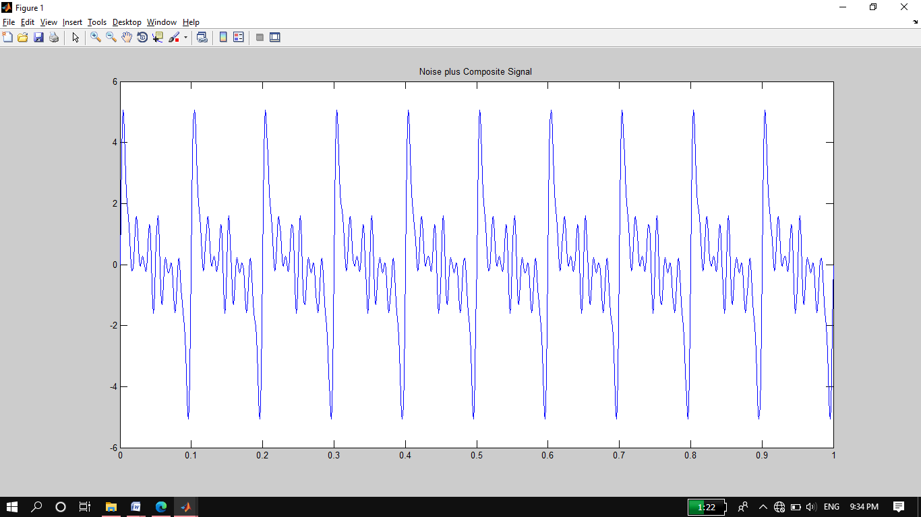

**Frequency domain representation of noise plus composite signal:**

**Code:**

n=length(variance);

yfft=fft(variance,n);

x=(-n/2:n/2-1)*(1000*n);

yshift=fftshift(yfft);

plot(x,abs(yshift));

title('Noise plus Composite Signal');

grid on

**Output:**

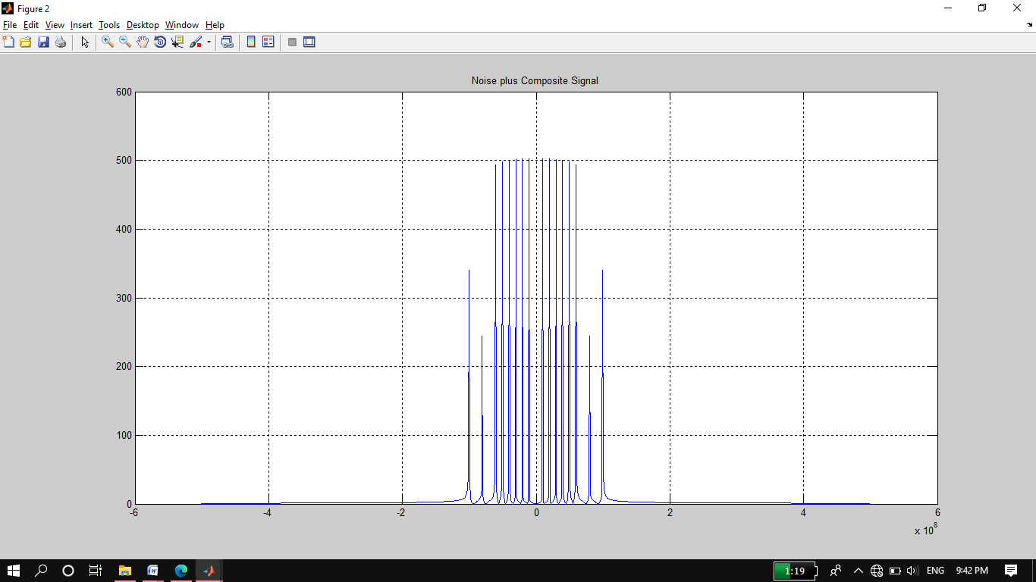

**Task 09:**

**Final Remarks/Conclusion**:

In time domain graph it is hard to analyze the signal as compare to frequency domain representation of signal. If look at the frequency representation of the signal then we see the all frequencies of given signals and easy to analyze the signal. In this lab report we generated different frequencies signals and obtained their time and frequency domain representations. To check if the signals are added how its time domain graph and frequency domain graph changes. We come to learnt about the time domain representation and frequency representations. Simply, a time-domain graph shows how a signal changes over time, whereas a frequency-domain graph shows how much of the signal lies within each given frequency band over a rang.